3rd URSI AT-AP-RASC, Gran Canaria, 29 May – 3 June 2022

URSI Student Paper Competition Template

First A. Author⁽¹⁾, Second B. Author* ⁽¹⁾, and Third C. Author⁽²⁾
(1) The ABC Company, Wash., DC, 20031, http://xxx.xxxx.xxx
(2) The Next Company, Neverland, USA

1. Introduction

These instructions provide guidance for the preparation of your Student Paper for an URSI Flagship conference. The margins and required spacing between different sections are demonstrated for author's convenience. To insert your text just highlight each section and replace with your own text. Otherwise, use this as a guideline to compare your final document in terms of margins, font sizes, and spacings.

2. Layout

The URSI Student Paper Competition (SPC) paper should be single spaced, single column and sized for A4 paper according to this template. The paper should be no longer than 10 pages.

The body text should be Times New Roman 10 pt. Sections should be titled and numbered in bold Times New Roman 12 pt. The top and bottom margins should be 2.5 cm (1 inch); the left- and right-hand margins should be 1.6 cm (0.63 inch). Paragraphs should be separated with one blank line. Do not indent paragraphs.

The title should be centered according to this template. The author’s (or authors’) name and complete organizational affiliation should be two lines below the title. If there are multiple authors, the presenter is to be identified with an asterisk. The text should start three lines below the last name.

3. Paper Content

The paper should include an abstract and the usual sub sections and should be in English.

Citations and references should follow IEEE format (as used by the Radio Science Bulletin). Citations can be of the form [1, 2] as is appropriate to the sentence, with the reference format illustrated at the end of this template.

4. Equations

Equations should be centered with the equation numbers right justified in the following format:

 | $$T^{'}=\frac{r_{e}^{2}λ^{2}GC_{s}L\sec{θ}\sqrt{π}Γ\left(\frac{p}{2}\right)}{4π^{2}Γ\left(\frac{p+1}{2}\right)}$$  . | - .

5. Figures and Tables

5.1 Figures

Figures should include a caption beneath the figure (in Times Roman 10) and the caption should include the Figure number in bold. Figure 1 provides an example.

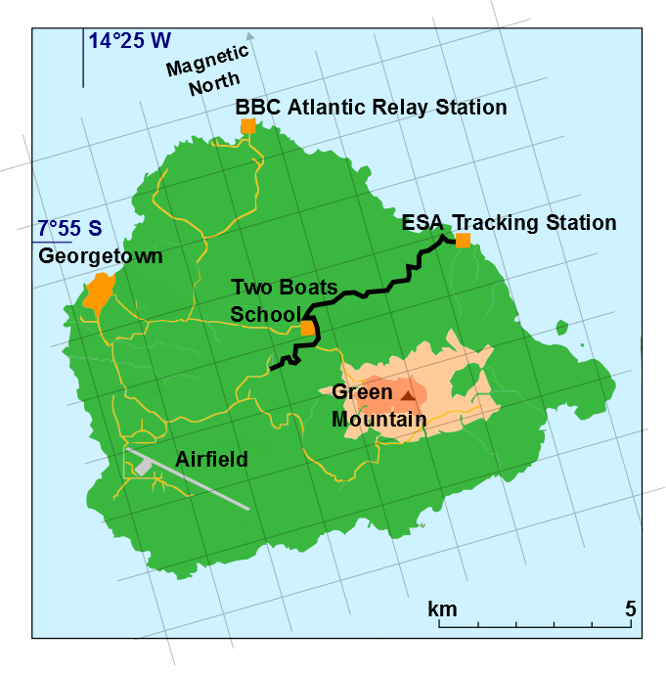
Figure 1. Ascension Island (7.9°S, 14.8°W showing the ESA Tracking Station which was the location of the fixed receiver and the road (shown in black) along which the mobile measurements were made).

5.2 Tables

Likewise, tables should include a caption (in Times Roman 10) but this time above the table. The caption should include the table number in bold.

6. Acknowledgements

Acknowledgements go in here.

References

[1]. P. S. Cannon, P. S., “Extreme Space Weather – A Report Published by the UK Royal Academy of Engineering,” Space Weather, 11, 4, April 2013, pp. 138-139, doi:10.1002/swe.20032.

[2]. C. R. Mannix, D. P. Belcher, P. S. Cannon, and M. J. Angling, “Using GNSS Signals as a Proxy for SAR Signals: Correcting Ionospheric Defocusing,” Radio Science, 51, 2, February 2016, pp. 60-70, doi: 10.1002/2015RS005822.

7. Export

All submissions will be electronic and in a PDF format (*.pdf) and all fonts must be embedded in the submitted PDF document.

Embedded Type 1 or True Type fonts are required in the submitted PDF file as subset fonts. Type 3 fonts (bitmaps) will not be accepted. Additional information on PDF creation is available on the submission Web site.

